**Project Design Phase-II**

**Data Flow Diagram & User Stories**

|  |  |
| --- | --- |
| Date | 24 June 2025 |
| Team ID | LTVIP2025TMID30989 |
| Project Name | Airlines Management System |
| Maximum Marks | 4 Marks |

**Data Flow Diagrams:**

A Data Flow Diagram (DFD) is a traditional visual representation of the information flows within a system. A neat and clear DFD can depict the right amount of the system requirement graphically. It shows how data enters and leaves the system, what changes the information, and where data is stored.

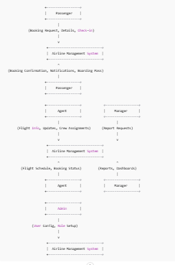

# User Stories

Below are the user stories for the Airline Management System, aligned with the project’s functionalities and Salesforce features.

|  |  |  |  |  |  |  |
| --- | --- | --- | --- | --- | --- | --- |
| User Type | Functional Requirement (Epic) | User Story Number | User Story / Task | Acceptance Criteria | Priority | Release |
| Passenger (Mobile/Web User) | Registration | USN-1 | As a passenger, I can register for the Airline Management System by entering my email, password, and confirming my password via the Lightning App. | I can access my dashboard in the Lightning App after registration. | High | Sprint-1 |
| Passenger (Mobile/Web User) | Booking | USN-3 | As a passenger, I can book a flight by selecting a flight and entering my details via the Bookings tab. | A booking record is created in Booking__c, and I receive a confirmation notification. | High | Sprint-1 |
| Admin (Web User) | Automation | USN-14 | As an admin, I can create a Flow to automate booking approvals. | A Flow is configured, and bookings are auto-approved based on criteria. | Medium | Sprint-2 |

---

# Notes

- DFDs: Visualize using Lucidchart or Visio. Circles = processes, rectangles = entities, open rectangles = data stores.  
- User Stories: Cover core functionality; more can be added on request.  
- Salesforce Features: Includes custom objects, tabs, Lightning App, Apex, Flows, profiles, roles, reports, dashboards.  
- Team ID/Project Name: Fill in as needed.